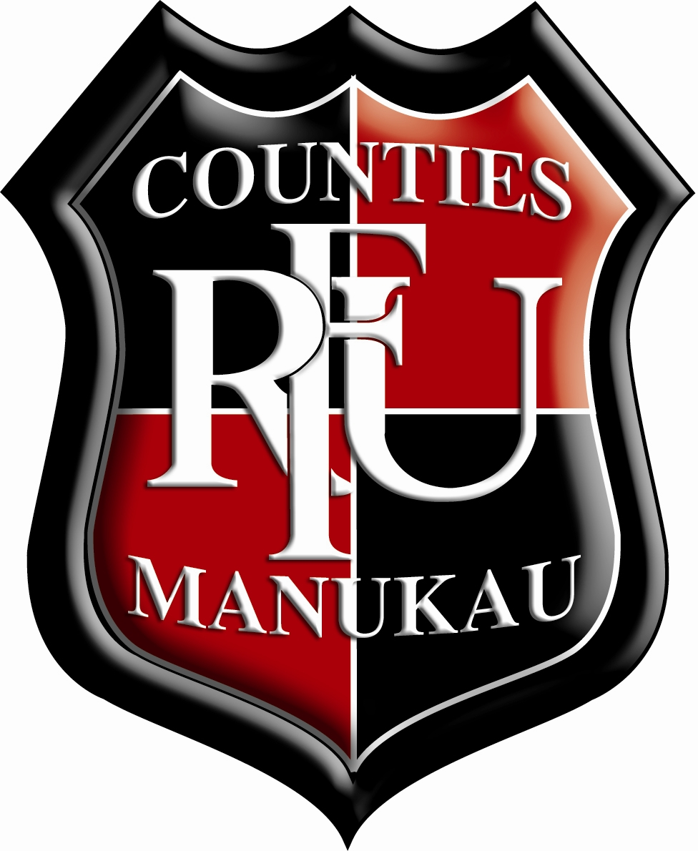 Counties Manukau Rugby Football Union
Director of Rugby and PIC Steelers Head Coach

Director of Rugby and PIC Steelers Head Coach

A great opportunity has arisen for a Director of Rugby to lead the Counties Manukau Rugby Football Union’s high performance programme as well as work as the head coach of the Bunnings Warehouse NPC team. As part of the role, the head coach will be expected to dedicate at least 50 percent of their time to support and champion the growth of amateur rugby within the Counties Manukau region and help us deliver on our vision to be the pride of our community.

The CMRFU was formed in 1955 and encompasses a very large catchment area which includes Manurewa Rugby Club in the north and extends down to the Te Kauwhata Rugby Club in the south. The region also spans from Waiuku Rugby Club in the west to Beachlands Maraetai Rugby Club in the east.

The CMRFU is the guardian of our national provincial teams (the PIC Steelers and the Counties Power Heat) as well as community rugby in the region. Counties has a storied history boasting legends of the game such as Jonah Lomu, Joeli Vidiri, Tana Umaga, Sonny Bill Williams, Kieran Read, Bruce Robertson and Andy Dalton. The PIC Steelers won the Ranfurly Shield in 2013 and are in the Championship division of the Bunnings Warehouse NPC after being relegated from the Premiership in 2019.

The Steelers finished sixth in the Championship in 2020. The priority of the head coach will be to build a top quality, sustainable high-performance rugby programme that produces athletes from our region (helping the best of them chase higher honours) while also putting together a team that is capable of winning the Championship and restoring Counties Manukau Rugby’s position amongst the leading rugby unions in the country.

The purpose of the Union is to grow, empower and inspire our people through rugby while our mission is to grow rugby at the grassroots while inspiring our community through sustained success.

The main priorities for the PIC Steelers head coach component of the role are to:

- lead, and be responsible for all aspects of our NPC campaign including, but not limited to, preparation and management, selection plan, and a periodised coaching and training programme;

- lead the squad selection management, the coaching strategies, values, standards, principles and mind-set for the coaching staff and players; and

- lead the technical and tactical coaching to individual players, mini-units and the team.

Meanwhile, in their capacity as the director of rugby, they will be expected to work with the Union’s chief executive officer and members of the high performance unit to:

- establish and implement an effective development pathway, selection process and succession plan for the players, coaches, managers and trainers in our region which ensures that our best personnel coach, manage, train and play in our representative teams; and

- create and oversee a very innovative and high-yielding high performance unit with a productive, accountable and winning culture.

- help grow participation in the community game

To be considered for this role, the person must be a leader with the necessary skills to drive the Union’s high performance strategic goals in our community. This must be backed up by strong personal qualities and a management style that connects, grows & inspires our people. The person must have excellent rugby acumen and be technically and tactically proficient in all areas of the modern game. We would expect the person to have a minimum of five years coaching experience in today’s current performance rugby landscape, preferably in a head coaching role, or an assistant coaching role at NPC Level (national domestic) or above, or as a successful coach at the Premier club level. The person must also exhibit a passion and desire to connect with our community game and possess a growth mindset exemplified by a philosophy of chasing constant improvement.

Expressions of Interest are also invited for the Assistant Coach Roles. The appointment of the Assistant Coaches may be done in conjunction with the Director of Rugby & Head Coach.

Applications can be sent to the Union’s CEO, Aaron Lawton, at aaron.lawton@steelers.co.nz. The closing date for candidates to submit applications is Monday, October 11 (5pm NZ time).

Job Description

POSITION TITLE: | Director of Rugby & PIC Steelers Head Coach | POSITION TYPE
REPORTS TO: | Chief Executive Officer | LOCATION: |  | Navigation Homes Stadium, Pukekohe
DATE: |  | REMUNERATION & BENEFITS
KEY WORKING RELATIONSHIPS: | CEO, Head of High Performance, Sport Science Manager, Counties Manukau Rugby staff, New Zealand Rugby Union, Chiefs Rugby Club, players, community coaches and managers.
PURPOSE OF THE ROLE: | To lead the Counties Manukau Rugby Union’s high-performance rugby programme, the union’s NPC team & provide community player and coach development services.
DIRECTOR OF RUGBY & MITRE 10 HEAD COACH

Management & Coaching (25%) | As the Head Coach of the Union’s NPC team, you shall be responsible for the following:  - Lead all aspects of, the NPC campaign including, but not limited to, preparation and management, selection plan, and a periodised coaching and training programme.  - Lead the squad selection management.  - Lead the coaching strategies, values, standards, principles and mind-set for the coaching staff and players in the following areas:  - Set piece  - Attack  - Defence  - Open play  - Lead the development of appropriate game plans, review and measure individual and team performance against these plans.  - Lead regular performance and development reviews/ feedback to each player with reference to match analysis information  - Lead Ideal team profile and season game plan and update this following selection of final squad to include patterns of play and individual player strength and weakness analysis.  - Lead technical and tactical coaching to individual players and mini-units within the team as appropriate.  - Fully utilise all available technologies (i.e. analysts, GPS, etc.) to analyse, understand and develop individual and team performance.  - Remain up to date with modern game development, including new laws and their impact on the game.  As the PIC Steelers Head Coach, you shall be a member of the Union’s management team which meets weekly to review and discuss plans, programmes, opportunities and issues.  Together with the CEO and other members of the Union’s high performance unit, you shall assist with the following:  - the Union’s High Performance Rugby Programme.  - the player development programme, including oversight of the Union’s under 19s, Bs, Heat and Sevens teams.  - Personal & Performance Player & Team Management reviews and appraisal (includes providing off field development support).  - Support Rugby Pathways Management (including Talent Identification & Recruitment processes).  - Lead a positive and constructive Relationship Management with NZ Rugby, Chiefs and with other Coaches- including international
Community Development (50%) | As the Director of Rugby and NPC team Head Coach:  - you shall support the Coach Development Manager to develop the Coach Development Strategy and Programme.  - you shall support the Rugby & Operations Manager in the community (Club and schools).  - you shall support the rugby pathway model at all levels.  - you shall be a resource for all of the region’s community coaches.  - you shall fully support the development of an integrated approach between the performance and community divisions.
Lead the Union’s Culture & Values  (Leadership & Culture 10%) | - Lead with integrity and ensure that there is a shared understanding and adoption of the union’s vision and standards.  - In particular, you should bring a sense of fun to your work along with an attitude of chasing excellence in all that you do.  - We value courage and a growth mindset and want someone who is uncomfortable with the status quo and prepared to take educated risks.  - You should also care about the Counties Manukau Rugby Football Union and understand and respect our rich history.  - You will provide leadership of the team and team management, holding yourself and your people to high standards.
Personal Qualities (15%) | - Strong administration and organisation skills.  - Builds and maintains strong personal and professional working relationships.  - Trustworthy, ethical; respected; high levels of personal integrity.  - People focused & self-aware.  - Deliver what is promised.  - Delivers on targets and within agreed timeframes.  - Sets and maintains high standards for self and others.  - Clear and accurate communicator.  - Growth mindset

